|  |
| --- |
|  |
|  |

|  |
| --- |
|  |
|  |

**Partner 1:** Death toll climbs in flood-hit India and Pakistan

**By Harmeet Shah Singh, Mukhtar Ahmed and Laura Smith-Spark, CNN**

Updated 2:50 PM ET, Sun September 14, 2014

**Srinagar, India (CNN)** -- The loudspeaker at a nearby mosque warned Ifat Najeeb what was coming.

Najeeb, 60, woke to warnings that a flood was imminent in the Gogjibagh region of Srinagar, Kashmir, where she and her husband live. Residents were advised to leave and move to safer areas.

"I woke up suddenly and felt something was wrong," Najeeb told CNN. "Soon there was a thud and our main gate had been flung open by gushing waters which were rising alarmingly." Moments later, water was pouring into Najeeb's home. "Within no time our first floor was inundated. We rushed upstairs to the third floor as we watched dreadfully the waters covered the second floor in no time as well," Najeeb said. Najeeb and her husband were rescued by authorities, eventually relocating to an unaffected area in uptown Srinagar.

They consider themselves lucky. "Mercifully, the waters did not rise beyond the second floor, otherwise I and my husband would not be alive to tell the story," she said.

Recent flooding brought by heavy monsoon rains has wrought death and destruction in India and Pakistan since the rains began on September 2. Floods aren't uncommon in Kashmir, but these have been particularly severe in terms of damage and loss of life. *Nearly 500 have lost their lives in both countries, officials tell CNN.*

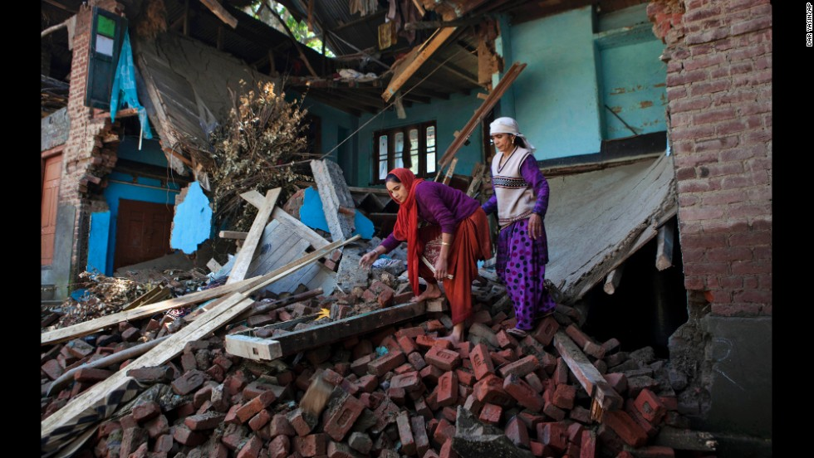

At least 280 people have been killed in Pakistan and more than 500 others injured, the government there said.

And at least 200 people have died in flooding in Indian-administered Kashmir, Indian Home Ministry spokesman Kuldeep Dhatwalia told CNN. "A number of villages have been washed away."

By Saturday, military and other emergency crews were able to rescue more than 276,000 people from parts of the flood-ravaged region under Indian control, according to officials.

Home to 12 million people, the state of Jammu and Kashmir is India's 19th most populous province.

Photos: Monsoon flooding - *South Asian monsoon's trail of destruction*

**Public anger:** Indian officials said rescue efforts continued on a massive scale, but refused to confirm reports that hundreds of thousands of people still remained stranded a week after floods wreaked havoc in the Himalayan valley.

Public anger has grown over the government response to the disaster in the restive mountain state, beset with decades-old militancy and a center of conflict between archrivals India and Pakistan.

# Partner 2: Crops in India Wilt in a Weak Monsoon Season

MURUMA, India — Vilas Dinkar Mukane lives halfway around the world from the corn farmers of Iowa, but the Indian sharecropper is at risk of losing his livelihood for the same reason: not enough rain.

With the nourishing downpours of the annual monsoon season down an average of 12 percent across India and much more in some regions, farmers in this village about 250 miles east of Mumbai are on the brink of disaster. “If this situation continues, I’ll lose everything,” said Mr. Mukane, whose soybean, sugarcane and cotton crops were visibly stunted and wilting in his fields recently. “Nothing can happen without water.”

Drought has devastated crops around the world this year, including corn and soybeans in the United States, wheat in Russia and Australia and soybeans in Brazil and Argentina. This has contributed to a 6 percent rise in global food prices from June to July, according to United Nations data.

India is experiencing its fourth drought in a dozen years, raising concerns about the reliability of the country’s primary source of fresh water, the monsoon rains that typically fall from June to October.

**By**[**VIKAS BAJAJ**](http://topics.nytimes.com/top/reference/timestopics/people/b/vikas_bajaj/index.html)SEPT. 3, 2012

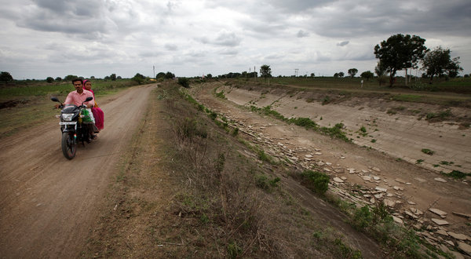

Villagers drive next to a dried up canal in Muruma, India.

**Partner 3-** Some scientists warn that such calamities are part of a trend that is likely to intensify in the coming decades because of climate changes caused by the human release of greenhouse gases.

A paper published last month blamed global warming for a large increase in the percentage of the planet affected by extreme summer heat in the last several decades…Scientists say that in addition to increasing temperatures, climate change appears to be making India and its neighbors Pakistan, Sri Lanka and Bangladesh more vulnerable to erratic monsoons.

Studies using 130 years of data show big changes in rainfall in recent decades, said B.N Goswami, director of the Indian Institute of Tropical Meteorology, a government-backed research organization. Climate models suggest that while overall rainfall should increase in the coming decades, the region can expect longer dry spells and more intense downpours — forces that would seem to cancel each other out but in fact pose new threats.

“Heavy rains are normally short duration, and therefore the water runs off,” said Dr. Goswami, who added that more research was needed to fully understand the impact of climate change on monsoons. “Weak rains are important for recharging groundwater.”

India is more vulnerable to disruption from drought than countries like the United States. While agriculture accounts for just 15 percent of India’s economy, half of its 1.2 billion people work on farms, and many of its poorest citizens already cannot afford enough food after price increases of 10 percent or more in the last couple of years.

“These kinds of rainfall failures have a lot of human effects,” said Yoginder K. Alagh, chairman of the Institute of Rural Management and a former Indian minister. “A large number of people don’t get employment. There are acute drinking water problems.” Food grain and oilseed production in India could fall up to 12 percent this year as a result of poor rain, said P.K Joshi, director for South Asia at the International Food Policy Research Institute.

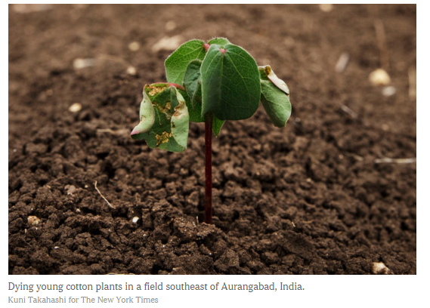 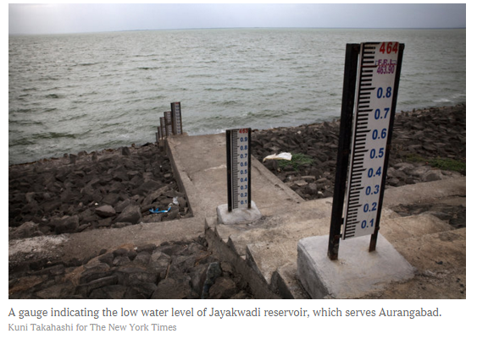

***Partner 4:***

The Indus River is the primary source of freshwater for most of Pakistan. It’s responsible for much of the water that’s used in both Pakistani households and industries. Water from the Indus also supports 90 percent of the agricultural sector in Pakistan—a particular problem for a country that, like others in the sub-tropical regions of the world, is arid and dry to begin with.

The Indus, like the Nile in Egypt, is one of the great rivers of the world. But the river has been so exploited in the past two decades—even as dry conditions grow worse in sub-tropical regions—that it no longer even flows into the ocean at the Port of Karachi.

The Indus is “dribbling to a meager end. Its once-fertile delta of rice paddies and fisheries has shriveled up,” water expert and author Steven Solomon has written in *The New York Times*.

Once a lush ecosystem, the lower Indus and the varied habitat it supports is now threatened in myriad ways.

“Choked off from its water supply, Karachi is plagued by increasingly brazen water thieves and riots over scarcity. Many in the water-stressed delta blame wealthy landowners upstream for taking water out of the river,” *National Geographic*reported in a special series on global water issues.

## [Will World War Three Be Fought Over Water?](https://www.sciencefriday.com/segments/will-world-war-three-be-fought-over-water/" \o "Will World War Three Be Fought Over Water?)

But here’s where it gets especially treacherous for Pakistan. Compounding the over-use and changes inflicted on the arid region from the Earth’s climate system, actions by India to cut off some of the flow of water feeding the Indus has created the potential for serious conflict between the two nations. The glaciers that feed the Indus originate in India, which has implemented large-scale diversions of the freshwater as it cascades down from those glaciers. India has even bigger plans for diversions. This, not surprisingly, has created considerable tension with Pakistan.

“One of the potentially catastrophic consequences of the region’s fragile water balance is the effect on political tensions,” *National Geographic*reported.